SAMBA SERVER
Package: Samba
Port number: 139, 445 and 137, 138
Configuration File: /etc/samba/smb.conf
Services: smb.service

Steps to Configure Samba Server
1. Install the Samba package:
# yum install samba
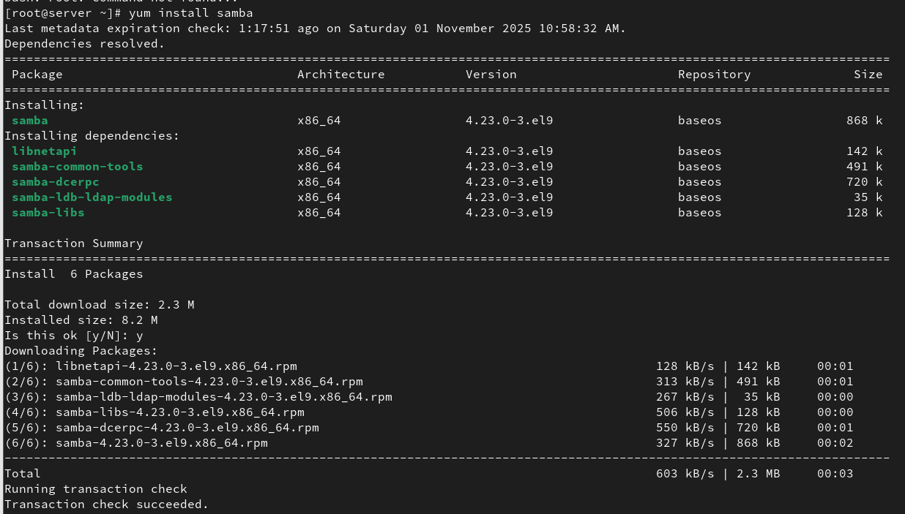

2. Modify the Samba configuration file:
# vi /etc/samba/smb.conf

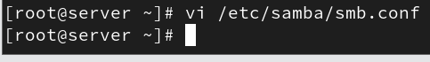
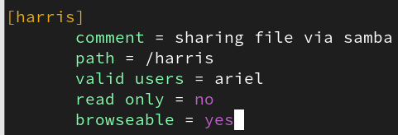

3. Start and enable the Samba service:
# systemctl enable --now samba

4. Create a Samba user and set an SMB password:
# useradd sambauser
# smbpasswd -a sambauser
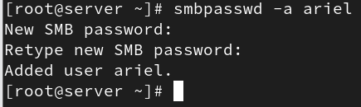

5. Install the Samba client package:
# yum install samba-client
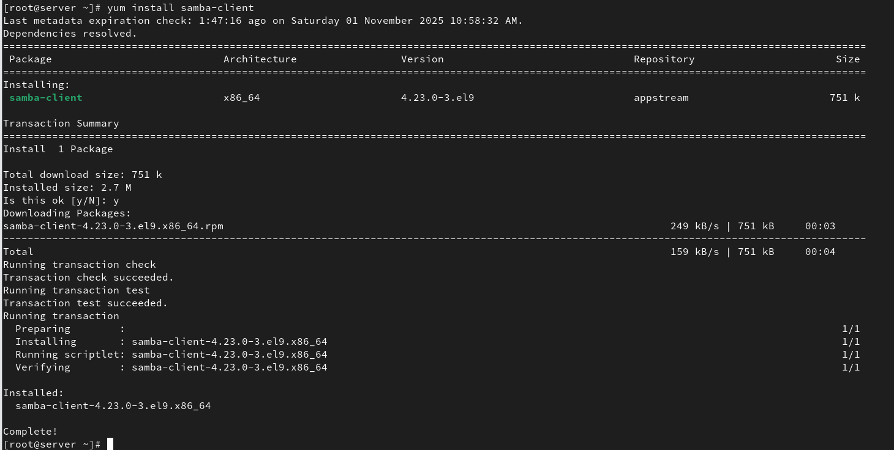

6. Ensure that the directory has been shared or not:
# smbclient -L \\localhost
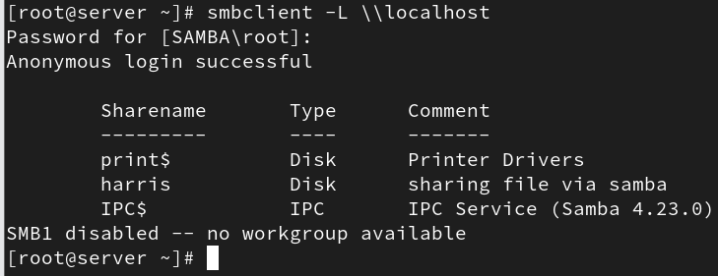

7. In Windows:
- Press Win + R
- Enter the shared folder path (e.g., \\<server_ip>\<share_name>)
- Enter the Samba username and password to access the files.
